ASSIGNMENT-1

Name: Sai Sree Varun Date: 02/05/2021

USN: 1JT17IS036

**Github :<https://github.com/Varunjitwta/WebTechClass>**

Program-2: Write a JavaScript that  
calculates the squares and cubes of the numbers from 0 to 10 and outputs HTML  
text that displays the resulting values in an HTML table format.

Program

<!DOCTYPE html>

<html>

<head>

<title>Squares and Cubes</title>

</head>

<body>

<table border="1" align="center">

<tr>

<td>Number</td>

<td>SQUARE</td>

<td>CUBES</td>

</tr>

<script type="text/javascript">

for(var i=0;i<=10;i++)

{

document.write("<tr align='center'><td>" + i + "</td><td>" + i\*i

+"</td><td>" + i\*i\*i + "</td></tr>")

}

</script>

</table>

</body>

</html>

Output: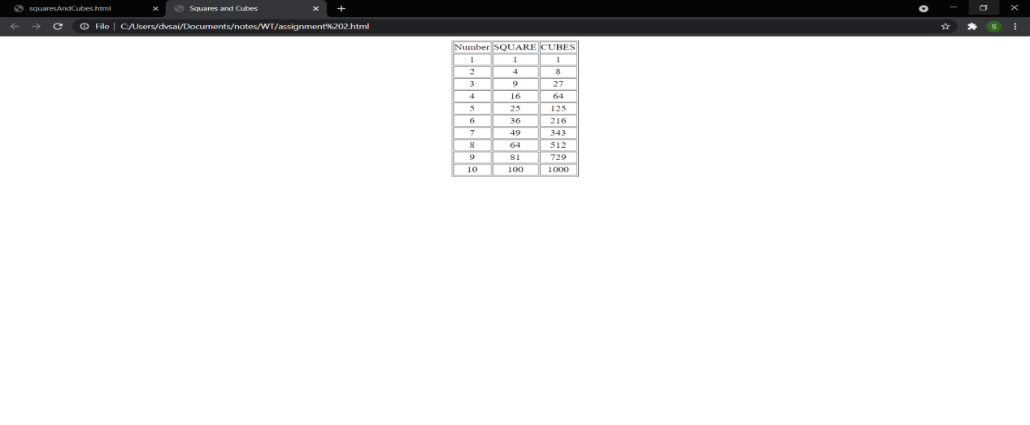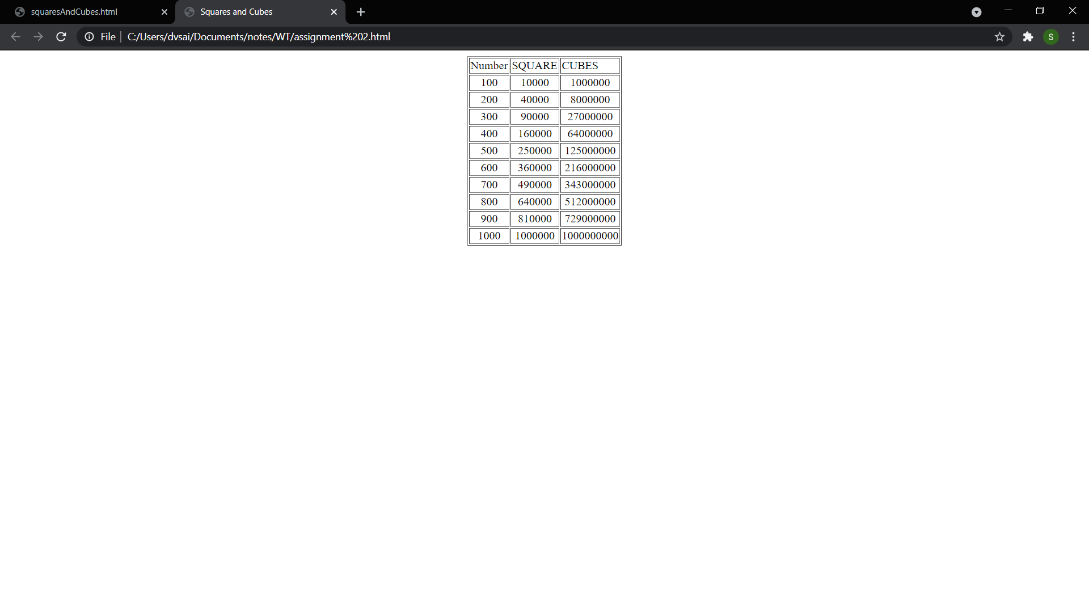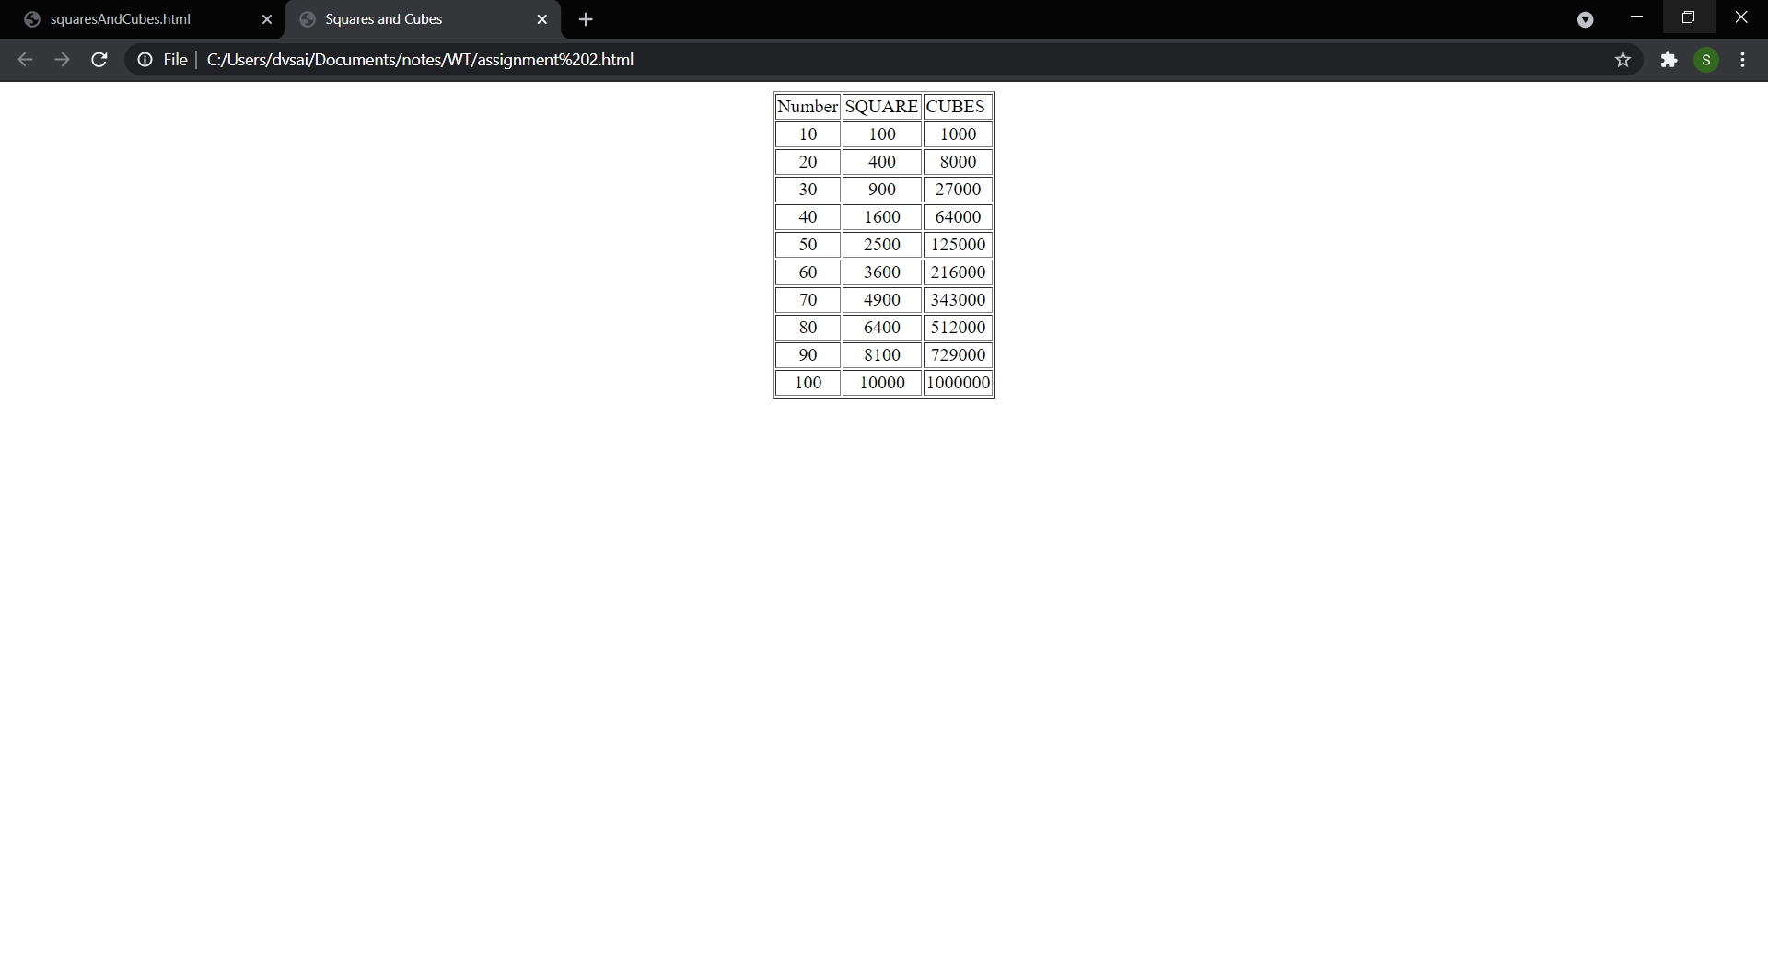

Challenge

Your assignment should like below with various test cases. a. Output should be like below image (as shown in the class) b. “Assignmen-2 Challenge Completed” should be blinking. c. Test case should be filled in as given in the below table.

Program:

<!DOCTYPE HTML>

<html>

<head>

<style>

table, tr, td, th

{

border: solid black;

width: 33%;

text-align: center;

border-collapse: collapse;

background-color:;

text-shadow:

}

table { margin: auto; }

p{

border: solid black;

font-size: 2rem;

text-align: center;

margin-top: 50px;

margin-left: 580px;

height:30vh;

width: 50vh;

line-height: 30vh;

color: #39ff14;

background: #000000;

font-weight: 70;

}

.blink {

animation: blink 1s steps(1, end) infinite;

}

@keyframes blink {

0% {

opacity: 1;

}

50% {

opacity: 0;

}

100% {

opacity: 1;

}

}

</style>

<script>

document.write( "<table><tr><th colspan='3'> NUMBERS FROM 10 TO 100 WITH THEIR SQUARES AND CUBES </th></tr>" );

document.write( "<tr><td>Number</td><td>Square</td><td>Cube</td></tr>" );

for(var n=100; n<=1000; n=n+100)

{

document.write( "<tr><td>" + n + "</td><td>" + n\*n + "</td><td>" + n\*n\*n

+ "</td></tr>" ) ;

}

document.write( "</table>" ) ;

</script>

</head>

<body>

<p>

<span class="blink">assignment 2 completed</span>

</p>

</body>

</html>

|  |  |  |
| --- | --- | --- |
| Test No | Input Parameters | Output Image |
| 1 | i=0 to 10,  increment of i+1 | squaresAndCubes.html - Google Chrome 10-05-2021 21_26_54 |
| 2 | i=10 to 100,  increment of i+10 | squaresAndCubes.html - Google Chrome 10-05-2021 21_27_15 |
| 3 | i=100 to 1000,  increment of i+100 | squaresAndCubes.html - Google Chrome 10-05-2021 21_27_28 |